section a: athlete details
First Name |  |  |  | Surname
Address |  |  |  | Postcode
Telephone |  |  |  | Mobile Number
Date of Birth  (DD/MM/YY) |  |  |  | Email Address* See note below
Preferred Events
*Please note: This is a required field, so England Athletics can invite you to access your MyAthletics portal to complete the registration process with them. England Athletics will not market to you without your express consent.

section B: PARENT/CARER DETAILS
If you are under 18 years of age, please ask your parent/carer to complete the following section.
First Name |  |  |  | Surname
Address |  |  |  | Postcode
Telephone |  |  |  | Mobile Number
Date of Birth  (DD/MM/YY) |  |  |  | Email Address* See note below
Preferred Events
*Please note: This is a required field, so England Athletics can invite you to access your MyAthletics portal to complete the registration process with them. England Athletics will not market to you without your express consent.

section C: ADDITIONAL SUPPORT
Please detail below any disability you have and/or any additional support you may require from our club coaches

section d: MEDICAL INFORMATION
Please detail below any important medical information that our coaches/junior coordinator should be aware of (e.g. epilepsy, asthma, diabetes, allergies, etc.) Please do not leave blank – if there is no information please write ‘None’.
This consent needs to be provided by the parent for children under the age of 13. Anyone over the age of 13 can provide consent for the use of data under GDPR

- I consent to my special category personal data provided in section C and D to be shared with coaches for the purposes of the delivery of my safe participation in Club activity. This data will not be shared or processed for any other purpose.

section E: EMERGENCY CONTACT DETAILS
Please insert information below to indicate who should be contacted in event of an incident/accident.
Emergency Contact 1 name:
Emergency Contact 1 number:
Emergency Contact 2 name:
Emergency Contact 2 number:
section F: Photography & Video ConsenT (Those aged 18 or under)
Cheddar Running Club recognises the need to ensure the welfare and safety of all young people in athletics. In accordance with the UK Athletics child protection policy and procedures, we will not permit photographs, video or other images of children/young people to be taken without the consent of the parents/carers and children/young people.

The Club will take all possible steps to ensure these images are used solely for the purposes they are intended. If you become aware that these images are being used inappropriately you should inform the Club immediately.

I, , consent to Cheddar Running Club(or a photographer appointed by the Club) photographing or videoing my child’s involvement in the running club for the period shown on this form for the purposes of publicising and promoting the club or sport, or as a coaching aid.
Signature
Print Name
Date:
section G: CLUB PRIVACY STATEMENT & COMMUNICATION PREFERENCES
Cheddar Running Club (The Club) take the protection of the data that we hold about you as a member seriously and will do everything possible to ensure that data is collected, stored, processed, maintained, cleansed and retained in accordance with current and future UK data protection legislation. Please read the full privacy notice carefully to see how The Club will treat the personal information that you provide to us. We will take reasonable care to keep your information secure and to prevent any unauthorised access.

In addition to receiving general club communications please let us know how else you would like to hear from us:

- I would like to receive Information via email from the Club about specially selected products and services available from commercial sponsors and partners
In addition to email, I am happy to receive communications via: Text € Telephone € Post €

section H: Data TRANSFER TO ENGLAND ATHLETICS
When you become a member of or renew your membership with Cheddar Running Club you can also choose to be registered as a member of England Athletics (you will have to register with England Athletics if you ever compete for the club in competition Under UKA Rules). If you tick the box below we will provide England Athletics with your personal data which they will use to enable access to an online portal for you (called myAthletics). England Athletics will contact you to invite you to sign into and update your MyAthletics portal (which, amongst other things, allows you to set and amend your privacy settings). If you have any questions about the continuing privacy of your personal data when it is shared with England Athletics, please contact dataprotection@englandathletics.org.
If you do not tick the box below and then decide to compete for the club, we will need to register you with England Athletics and we will inform you at that time.

□ I want to join England Athletics □ I don’t want to join England Athletics at this time

SECTION I: MEMBERSHIP TYPE AND PAYMENT METHOD
Membership Type | Price | Required: Yes or No
Cheddar Running Club Junior Membership | £10
Cheddar Junior Membership and England Athletics | £26
Cheddar Running Club Membership Only | £20
Cheddar Running Club and England Athletics | £36
Payment Method
Bank Transfer 30-91-84 00157480 (Please use surname and ‘subs’ as reference)

SECTION J: ATHLETE/PARENT
By returning this completed form, I confirm that I have read and understood the privacy notice (on the following pages) and how data will be used and shared and am willing to abide by the Club code of conduct for athletes [and parents].
Signature
Print Name
Date

We look forward to welcoming you and your family to the Club in the near future.

To find out all the latest Club information, please visit our website:

cheddarrunningclub.co.uk

Privacy Notice
Cheddar Running Club are committed to protecting and respecting your privacy. For any personal data you provide for the purposes of your membership, Cheddar Running Club is the Data Controller and is responsible for storing and otherwise processing that data in a fair, lawful, secure and transparent way.
What personal data we hold on you
You may give us information about you by filling in membership forms or online, or by corresponding with us by phone, e-mail or otherwise. This includes information you provide when you register with the Club or participate in discussion boards on our website, Facebook Page or Twitter feed. The information you give us may include your name, date of birth, address, e-mail address, phone number, name of the EA affiliated Clubs with which you are registered and gender (Athletics Data).
Why we need your personal data
The reason we need your Athletics Data is to be able to administer your membership, and provide the membership services you are signing up to when you register with the club. Our lawful basis for processing your personal information is that we have a contractual obligation to you as a member to provide the services you are registering for.
Reasons we need to process your data include:
For membership and club management
- processing of membership forms and payments;
- sharing data with committee members to provide information about club activities, membership renewals or invitations to social events;
- Race reports promoting club activity; and
- Publishing of race and competition results (including any photo’s you provide for us to use in line with this) both on our website, social media pages and distribution to the local press.
For training and competition entry
- sharing personal data with club coaches or officials to administer training sessions;
- sharing personal data with club team managers to enter events;
- sharing personal data with facility providers to manage access to the track or check delivery standards; and
- sharing personal data with leagues, county associations (and county schools’ associations) and other competition providers for entry in events.
For funding and reporting purposes
- sharing anonymised data with a funding partner as condition of grant funding e.g. Local Authority;
- sending invitations for occasional surveys using Survey Monkey, e.g. to improve your experience as a Club member, or to vote on Club-related matters.
Marketing and communications (where separate consent is provided)
- sending information about promotions and offers from sponsors or about events that may be of interest to Club members;
- sending information about selling club kit, merchandise or fundraising.
We process this data on the lawful basis of consent. Therefore, we will also need your explicit consent to process this data, which we will ask for at the point of collecting it.
On occasion we may collect personal data from non-members (e.g. such as any non-member participant who applies to run our club race, fills in a health disclaimer or form at a taster event). This information will be stored for 18-months after an event (or before if requested) and then destroyed securely. Our lawful basis for processing data is consent. Therefore, we will also need explicit consent from non-members to process this data, which we will ask for at the point of collecting it.
The club has the following social media pages [Facebook, Twitter]. All members are free to join these pages. If you join one of the Social Media pages, please note that provider of the social media platform(s) have their own privacy policies and that the Club do not accept any responsibility or liability for these policies. Please check these policies before you submit any personal data on the Club social media pages.
Who we share your personal data with
When you become a member of the Club you can also choose to be registered as a member of England Athletics Limited. If you would like to register as a member of England Athletics Limited, please tick the box on the Cheddar Running Club membership form, and we will provide England Athletics Limited with your Athletics Data which they will use to enable access to the MyAthletics online portal. England Athletics Limited will contact you to invite you to sign into and update your MyAthletics portal. You can set and amend your privacy settings from the MyAthletics portal. If you have any questions about the continuing privacy of your personal data when it is shared with England Athletics Limited, please contact dataprotection@englandathletics.org. If you do not tick the box, then we will not share your data with England Athletics Limited. Please be aware that if you compete in an event as an affiliated Club member, you will need to be a fully paid up member with England Athletics Limited at that time or risk disqualification.
The Club does not supply any personal data it holds for this purpose to any other third party. The Club’s data processing requires your personal data to be transferred outside of the UK for the purpose of cloud storage with Google Drive. Where the Club does transfer your personal data overseas it is with the appropriate safeguards in place to ensure the security of that personal data.
How long we hold your personal data
We will hold your personal data on file for as long as you are a member with us; if you do not renew your membership by 30th May following the previous membership year end, i.e. 31st March, then you will cease to be a member with Cheddar Running Club. Athlete data is updated every year on annual membership forms. Any personal data we hold on you will be securely destroyed after five years of inactivity on that member’s account, in line with England Athletics Limited’s retention policy. Your data is not processed for any further purposes other than those detailed in this policy.
Data Breach
The ICO will be informed of any data breaches within 72-hours of such an event. Examples of personal data breaches include, the loss of a USB stick or the theft of a laptop.
Your rights regarding your personal data
As a data subject you may have the right at any time to request access to, rectification or erasure of your personal data; to restrict or object to certain kinds of processing of your personal data, including direct marketing; to the portability of your personal data and to complain to the UK’s data protection supervisory authority, the Information Commissioner’s Office, about the processing of your personal data.
As a data subject you are not obliged to share your personal data with the Club. If you choose not to share your personal data with us we may not be able to register or administer your membership.

Useful information for new members:
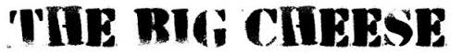 | The club organises a 15 mile fell race annually in early March, The Big Cheese. This raises thousands of pounds for charity and to allow it to happen we need all members to act as marshals on the day and to bake a cake for our famous cake table. While this means you can’t run the race, it allows you to return the favour of marshals at the events you attend!
 | In addition to our public facebook page, we have a members group for general running related chat and organising club runs (although all social and organised events will also be sent out by email if you have subscribed to this in on the membership form):  https://www.facebook.com/groups/CheddarRunningClubMembers/
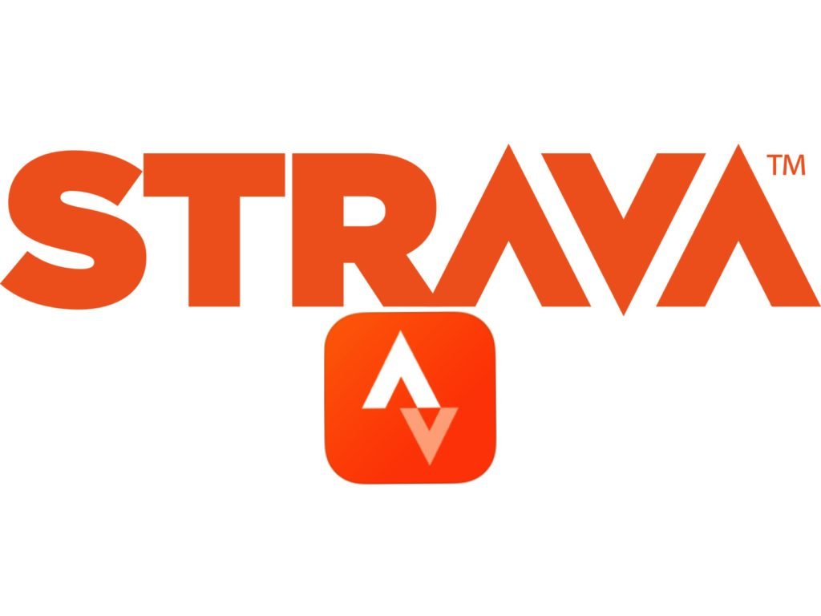 | We have a club group on Strava, which is a running (and cycling) tracking and social network site. Members of all abilities are on this and it is a lovely supportive community, so come and join us on there if you track your runs by GPS watch or app. Use Mapmyrun, endomondo or garminconnect already? No problem- you can link your accounts and get the best of all apps! https://www.strava.com/clubs/16127?hl=en-GB
 | We’d love to get to know you better! Please fill in our “member profile” and send it along with your favourite running picture so we can add you to the website. You can read other member profiles and download the form here: http://cheddarrunningclub.co.uk/members/meet-the-club/

